1. questions:

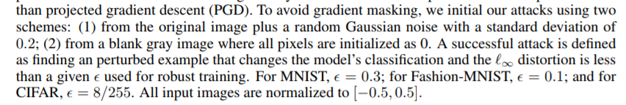

1. target or not
2. mnist natural (according to the initial setting in the json file)

1_0

60.020000% 🡪 99.17%

0.9_0

45.070000%---> 99.16%

0.9_0.05

20.460000%--> 99.13%

0.8_0

34.820000%--> 99.14%

99.17%

0.9_0.15

99.17%